Kip Taylor

Database

Homework 1

Some models shown were used from the internet due to the importance of the visual element. * ( I don’t see a problem with this nor does the syllabus or the assignment notes, but if there are any issues please reach out, they seems quite useful though in delivery of the concepts)

1. Discuss the following terms with simple examples. [15 points]
2. Transaction -  **A transfer from one bank account to another. Showing the transaction requiring subtraction from one account to be added to the other one**
3. Atomic Value – **a value that cannot be divided: Best example I could find** 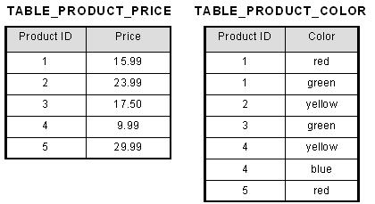
4. Database schema **- A database schema is a visual and logical architecture of a database created on a database management system.** 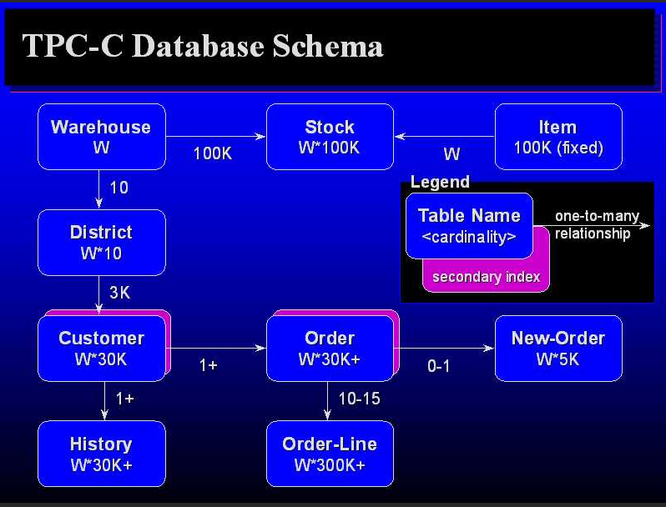

**Best example that defines it easily.**

1. Considering the following schema of a bank database (in hw assignment)
2. **Branch – branch_name – Primary Key , branch_ID, branch_name, branch_city = Candidate key.**

**2a. Customer – customer_name = Primary Key ,** **customer_name, customer_name, customer_street = Candidate Key**

**3a. Loan- loan_number – Primary Key, loan_number, loan_number, branch_name = Candidate key**

**4a. Borrower- loan_number = Primary Key, loan_number, customer_name, loan_number = Candidate Key**

**5a. Account- account_number = Primary Key, account_number, account_number, branch_name = Candidate key**

**6a. Depostier- account_number= Primary Key, account_number, customer_name, account_number = Candidate Key**

1. 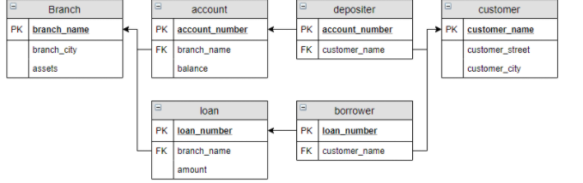
2. **Answer Below:**

**π customer_name (σ customer_city = 'Kent'(customers))**

**π customer_name (σ borrower.loan_number = loan.loan_number AND amount > 5000 (borrower y loan))**

**π customer_name (σ account.account_number = depositer.account_number AND balance > 9000 AND branch_name = "Kent" (account y depositer))**

1. **Cartesian-product is multiple of two table. Every row of table 1 will be combined with all the rows of table 2, if Table 1 have 2 rows and Table 2 have 3 rows then there cartesian-product will have 2x3 = 6 , In Math, a Cartesian product is a mathematical operation that returns a product set of multiple sets.**

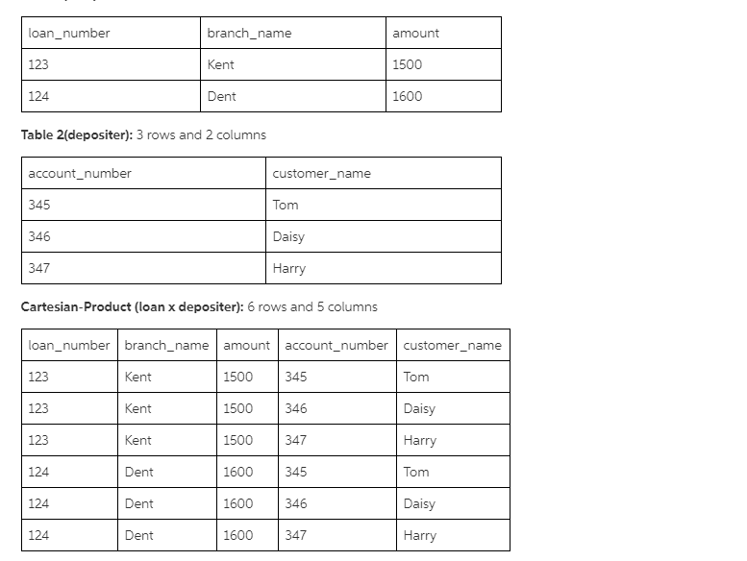

**The diagram should show how it works, and the importance:**

**Cartesian-product is important, sometimes when select command is done and when columns are required from both the table, then this is done using cartesian-product and this operation is also known as joining. This helps joining the table in ralational data model and helps to select things from both the table. It denotes by symbol 'X'.**

1. List superkeys and candidate keys of the following relation schemas of hospital database(15)
2. Relation Name : Doctors

Super Keys:

DoctorID}, {email}, {DoctorID, email}, {DoctorID, Name, MailingAddress, Salary},

{email, Name, MailingAddress, Salary}, {DoctorID, email, Name, MailingAddress, Salary}

Candidate Keys:

{DoctorID} , {Email}

Relation Name: Patient

Super Keys:

{PatientID}, {SSN}, {PatientID, SSN}, {PatientID, SSN, name}, {PatientID, name, address}, {SSN, name, address}, {PatientID, SSN, name, address}

Candidate keys:

{PatientID} , {SSN}

Relation Name : VisitingRecords

Super Keys:

​​​​​​​{PatientID, DoctorID}, {PatientID, DoctorID, DateOfVisit}

Candidate Keys: {PatientID, DoctorID}

1. 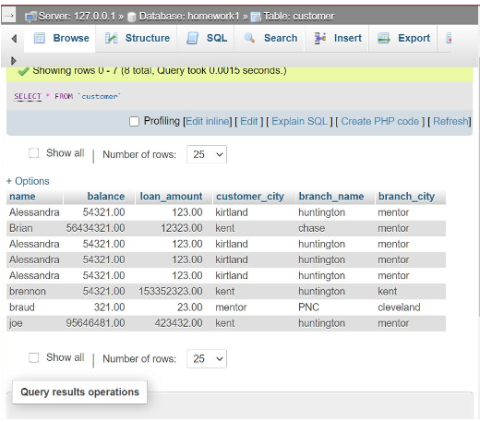

Hope that works!